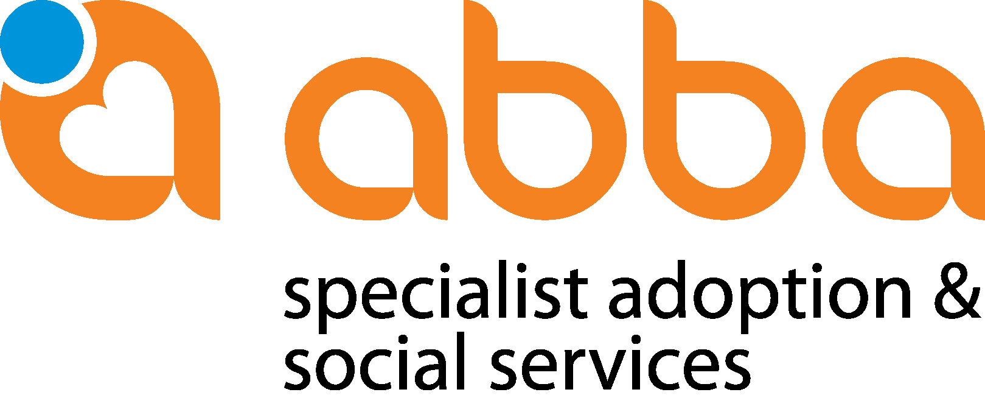

POST ADOPTION SERVICE NOTICE AND MANDATE
Dear adoptive parent/adoptee, welcome back! To best assist you through your roots/origin journey we would request that you complete this notice as complete as possible. Once we have received this, we will contact you to arrange an electronic orientation session in which we will provide you with information regarding the adoption origin enquiry process as well as the estimated costs involved (Regulation 107 of the Children’s Act).
Please note that we will do our best to assist with your origin search process in line with South African legislation (Children’s Act, 38 of 2005 as amended) which provide that the SA Adoption Register may be disclosed to an adoptee who reached the age of 18 years and/or the adoptive parents as well as the biological parents. The Act further stipulates that biological parents may only receive information with the consent of the adoptee/adoptive parents.
As this process forms part of the legal adoption, Abba and the mediation organization is responsible to provide the legislated counselling before disclosing any information contained in the adoption register. We therefor also recommend the involvement and support of the adoption mediation organization/independent psychological professional.
To ensure legal compliance we therefor request a written mandate to disclose information to the relevant parties involved.
CONSENT TO DISCLOSE INFORMATION:
I, …………………………………………………..(adoptee above 18) hereby give permission that information of the origin search may be disclosed to the relevant mediation organization
YES NO

I give permission that information of the origin search may be disclosed to my adoptive parents.
YES NO

I further give permission that information of the origin search may be disclosed to my biological parents.
YES NO
BACKGROUND INFORMATION AND EXPECTATIONS

- DETAILS OF THE ADOPTIVE PARENTS:
 | PARENT 1 | PARENT 2
SURNAME
FULL NAME
ADDRESS/ COUNTRY OF ORIGIN

- DETAILS OF THE ADOPTEE CONCERNED:
SURNAME
FULL NAME
PLACE OF BIRTH
AGE AND BIRTH DATE
HIGHEST QUALIFICATION
DATE OF ADOPTION
BIOLOGICAL NAME AND SURNAME

- DETAILS OF THE BIRTH PARENT/S:
 | BIOLOGICAL MOTHER | BIOLOGICAL FATHER
SURNAME
FULL NAME
ADOPTION AGENCY INVOLVED
PLACE OF SAFETY INVOLVED
(Shelter, Baby home, Temp safe care parent/s)

- PLANNED DATE OF VISIT ……………………………………………………………………………………..

- MOTIVE/NEEDS FOR ENQUIRY (indicate which options are applicable and motivate)
ROOTS ENQUIRY FOR UNDER 18

DISCUSSION OF ADOPTION RELATED MATTERS WITH THE SOCIAL WORKERS
MEETING WITH PREVIOUS CAREGIVERS
(IF POSSIBLE)
MEETING WITH BIOLOGICAL PARENTS
(Origin Enquiry – Above 18 years)

- To complete additional questionnaire

- EXPECTATIONS (Please have both completed)
ADOPTIVE PARENTS EXPECTATIONS | ADOPTEE’S EXPECTATIONS
PLEASE NOTE:
- A minimum period of 6 months -notice is required to facilitate this enquiry
- In accordance with South African legislation (Children’s Act 38/2005) meeting of the biological parents as an option may only be initiated if the adopted child is 18 years or older
- Once 18 years old the child and the adoptive parents need to provide permission to disclose file contents in writing before attempts will be made to trace the biological parent/s
- The biological parents may/or may not be traced
- The biological parents may/may not agree to the request to re-connect
- All attempts to trace the biological parents directly/ PERSONALLY or via Social media platforms are NOT seen as best practice and privacy of ALL parties should be respected ALWAYS.
- Counselling is compulsory before contact with biological parents
STATEMENT BY ADOPTIVE MOTHER AND ADOPTIVE FATHER
I/ WE, __________________________________________ AND
_________________________________________
GIVE PERMISSION THAT AN ORIGIN ENQUIRY PROCEED. I/we GIVE PERMISSION THAT THE FILE CONTENTS MAY BE DISCLOSED.
Signed at: ________________________on this_____day of___________________20___

ADOPTIVE FATHER: ______________________ ADOPTIVE MOTHER: ____________________________
STATEMENT BY ADOPTEE
I, _________________________________________________, BORN ON_________________________
AM ___________________YEARS OLD AND HEREBY GIVE PERMISSION THAT AN ORIGIN ENQUIRY PROCEED. I GIVE PERMISSION THAT THE FILE CONTENTS MAY BE DISCLOSED.
Signed at ___________________________on this __________day of _________________20 ________
Signature: _______________________________

FOR OFFICE USE

File nr:
Planned visit date:
Social worker/ role players involved:
File checked:
Invoice delivered to:
Payment received:
Adoption unit approved feedback:
Adoption unit recommendation re feedback/meeting:

